Ex8. Building a Web API

Write a program to build a Web API according to the lecture (section 3.2)
(Using .NET core + Entity Framework, SQL server or NodeJS + Mongodb)
The Web API provides the methods: GET, POST, PUT, DELETE for working with data models
- SensorData model
public class SensorData
{
public int Id { get; set; }
public string SensorName { get; set; }
public float SensorValue { get; set; }

}
- User model
public class User
{
public int Id { get; set; }
public string UserName { get; set; }
public string Password { get; set; }
public string Email { get; set; }
}
List of API on Swagger UI:
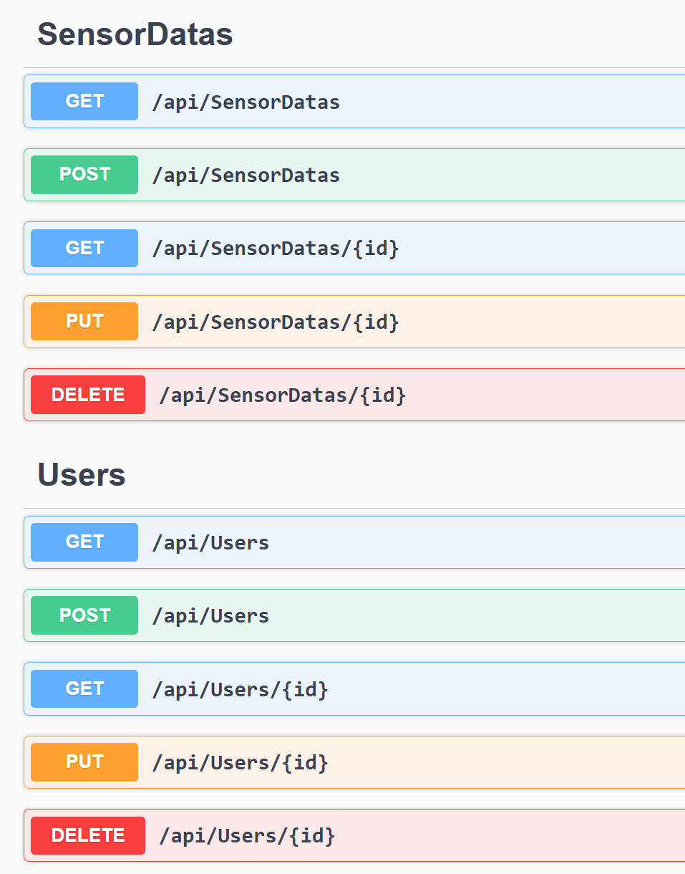
Example of running API:
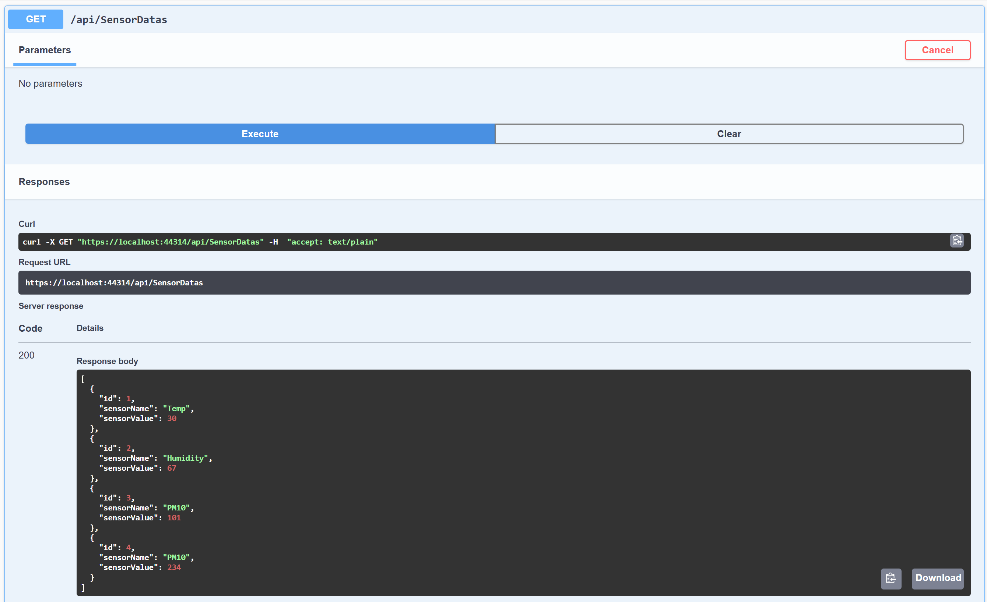
Submission:
Write a report describing: code, screen captures show the demo of program and results.

